INTRODUCTION
Pascal Secondary School is a private school founded in 2010. It is situated in Dong Anh district, surrounded by the country side. The school teaches around 150 students, ranging in age from 11 to 15 years. There are 4 English teachers who follow the governmental English teaching plan. The children do have some knowledge of English, but as it is often the case with Vietnamese students that they have poor pronunciation and confidence due to their lack of contacts with English speakers.
Each class has one Vietnamese English-teacher and around 30 students.
Pascal school is located in suburban area which is limited access to modern and qualified teaching institutes. The school aims to create and provide a friendly and inspiring learning environment for the students in that disadvantaged area. Thinking of the difficult backgrounds of the majority of the students in the area, the school just applies a similar school fee with public ones, which is based on the living standard of local people. With the modest income, the school’s management board is still managing to provide adequate facilities to create favorable conditions for the students to study, focusing on learning English – one of the necessary tools for the students to further develop in the future.

VOLUNTEER’S ROLE
There are many opportunities here for volunteers. Judging from past experience with similar programs we are convinced it will be a very rewarding experience. Both children and teachers are keen on working with volunteers and learning from them, and the children, as in other programs, love the company of foreigners and thoroughly enjoy communicating and playing with them.
The main task of volunteers in Pascal Secondary School is teaching English. The volunteers are in charge of teaching Listening and Speaking classes according to the governmental English books. Besides, they are in charge of teaching four extra English classes using the Solution Books and other teaching documents given by the school as reference.
The volunteers run the classes the whole time and the Vietnamese teachers will support in managing the class and in translating if needed. The lesson plans, materials and activities are prepared by volunteers as well. Volunteers can make a really meaningful contribution to the improvement of the students through more participative methods, involving the students in a more active learning, using funny games or activities.
The Vietnamese teachers will work together with volunteers to discuss further on the lesson plan for the whole duration of each volunteer since they start their first day at the school.
Though the children at Pascal Secondary School are getting used to foreigner visitors, they enjoy having the volunteers around. Due to their warm reception, volunteers generally become equally fond of the children and enjoy the program very much.

WORKING TIME
The volunteer participates in different classes per day, working from Monday to Friday, from 8:30 to 16:10. One period lasts 45 minutes.
Students have around 2 hour’s lunch break from 11:30 am to 13:45 pm.

LUNCH
Volunteers have lunch at the school.

TRAVEL TO WORK
Up to now, the chairman of school has been picking up volunteers from accommodation to the school by car because of far distance and lack of direct public buses. If he is busy, a taxi will be called to bring volunteers back home.
CONTACT:
At Pascal School:
The mentor at Pascal school is Mrs. Ha.
Address: Nam Hong, Dong Anh district, Hanoi.
Phone number: 01665836508
E-mail: hantv.pascal@gmail.com
The mentor is the person who will be in charge of the volunteer in the placement. Contact her to:
- Inform when you are sick or late, if it is possible one day in advance because they need to know to make the work schedule.
- Ask for information about organizational issues: logistics, timetable, meals, sleeping room after lunch, work material, etc.
- Ask for help related to problems at work. Usually the mentor is an English teacher. As she can speak English she will be helpful and will try her best to be a translator between the local staff and the international volunteer.
At VPV:
The project coordinator is Mai.
Address: No.56, lane 99, Nguyen Phong Sac Street, Cau Giay, Hanoi, Vietnam
Phone: 0129 222 7515
E-mail: individual@vpv.vn

CHALLENGES AND RECOMMENDATIONS
The volunteer can ask to observe the teachers’ or the other volunteers’ lessons during the first two weeks. We kindly recommend doing this short training to understand the dynamic of Vietnamese classes and to learn some tricks from the local teachers in big size Vietnamese classes.
Teachers have some specific programs to teach and sometimes they do not have enough time to finish it on time, which is the reason why the speaking and pronunciation part of the class is reduced in order to have more time for the book exercises. It is common to use the speaking part of the class to correct pronunciation problems instead of giving the volunteers the opportunity to prepare games by themselves. Be patient and proactive; even if you cannot prepare activities everyday do not lose motivation to propose new games or activities for the class. Remember that your support to the local teachers is also really important for the development of the children’s English skills.

DOS AND DON’TS
- Dress more conservatively when teaching at the school. It is not considered appropriate showing knees or shoulders.
- Contact your coordinator from VPV if there is any misunderstood between you and the teachers. Or if you need any advice to communicate with the staff and teachers from school effectively and friendly.
- Do not smoke at the school, even in the garden or open-air areas. It is a bad model for the children or adolescents. Neither give nor accept cigarettes from teenager students. If you are a smoker please leave the school area to smoke.
- Do not lose your temper in public. Even if you are frustrated or feel that you are being mistreated, to show anger will be seen as a serious loss of face and will rarely help you achieve what you want. It is more effective to smile, show patience and ask again about what you need.
- Do not correct the English teacher in front of other teachers or students. You should avoid hurting the others feelings. During your speaking and pronunciation exercises you will have the chance to correct all the mistakes you feel necessary to correct.

BASIC TIPS
- Speak slowly, repeat often
- Write things you are saying on the board if you notice that the children are not understanding you
- Walk through the class during class, explain the task again to single students, make them work and take away Math books, comics, letters...
- Create as many different games related to the topic as possible. The students love games/ activities
- Explain the task from the book in your own and more simple words
- The students are competitive. Divide the class into teams or use rows. They love teams.
- Don’t let them use their solution books (or you’ll have exactly the same dialogues and same opinions from all students).
- Don’t let them do what they are not supposed to do with the other teachers. You might want to be their friend but then you’ll lose their respect as a teacher.
- Don’t be surprised about the partly strange English in the school books
- They are intelligent students. Keep varying lessons but do not overdo the games (Hangman can be used to introduce a topic)
- Use the ESL web sites to find materials and word search maker sites to give relevant word searches
- Do not put up with mobile phones, talking over other students
- Do not put up with bad behavior. The school teachers will deal with it if you ask for their help.

PHOTO GALLERY

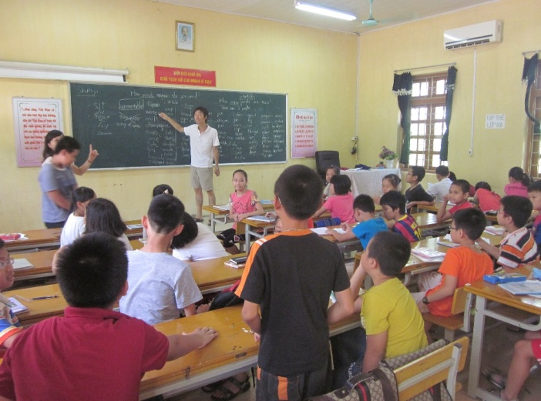 | 