INTRODUCTION
The PhucTue Caring Center is a non-profit, non-government day care organization based in Hanoi for the care of mentally and physically impaired children. The Center was established in June 2001. There are now 2 centers around Hanoi that provide care and education for approx 85 children and young people (aged 2 to 22yrs old) who are suffering from the effects of agent orange, autism, down syndrome and Japanese encephalitis. The Center’s aim is to look after these children and to help them integrate into normal society.
Number of staff: 12 teachers. All of them graduated from Hanoi National University of Education. Mrs. Huong, the director, is also the enthusiastic teacher that founded this center.
Number of children: Approximately 65 disabled children divided into 6 classes. The number of children changes from time to time.
The center’s mission is to provide opportunities for children with mental and physical impairment to receive an education and to feel included with their local community. In particular, the center provides assistance for those children suffering from developmental disabilities including Down's Syndrome, Autism and Cerebral Palsy. As well as early grade academic learning, the education programs include physical education and therapy, yoga, painting and poetry.
VOLUNTEER’S ROLE
- Caring for disabled children
- Creating suitable methods to teach the individual kids maths, life skills, etc
- Calling for charity or Subscription (depends on volunteers)

Detail tasks:
In the classes for autistics:
- Playing with the children with provided toys
- Helping them do some movements (walking, standing up or jumping…)
- Teaching them how to wash their hands, faces or wear clothes…
- Assisting the nurse to do rehabilitation activity
- Taking them out of the center for a walk
In the classes for children with intellectual disabilities (mental retardation):
- Assisting teachers in Math, Vietnamese writing lessons and basic English.
- Helping the children with drawing, coloring, lego games, puzzles…
- Assisting the teachers to teach some kids how to use computer in basic skills
WORKING TIME
The center starts working at 8:00 a.m but volunteers can work from 9:00 am. Volunteers will work until 11:00 and have a long break from then to 2:00 p.m. The afternoon section lasts until 4:00-4:30 p.m.
LUNCH
There are several options for lunch.
Due to the long lunch break, volunteers can also go back to VPV house to eat lunch. In this case, volunteers just need to tick for their meals on the meal list in the house one day in advance.
If prefer, volunteers can eat at some street restaurants nearby the Phuc TueCenter. In this case, volunteers get support of 40.000VND for lunch. They will pay in advance and get the reimbursement on a weekly basis.
Here are some common dishes with prices:
+Noodles (any kinds): 35.000-40.000 dong/bowl.
+Rice: 35.000-40.000 dong/dish.
(Give the money to the seller and point at the food that you want, the seller will pick them into your dish until it reaches the limit of your money)
An email is required to send to admin@vpv.vn stating number of lunch and respective date. VPV admin will check and reimburse money (30,000VND*number of lunch) to volunteers on an agreed date/time.

TRAVEL TO PROJECT
Volunteers normally take the bus number 14 to the project, which costs 7,000 VND per ride. Volunteers need to collect the bus tickets and give to VPV admin to get reimbursement (same procedure with lunch refund). Those who stay more than two weeks should provide a picture to VPV to make a bus pass. With the bus pass, volunteers just need to show it to the ticket inspector on the bus.

CONTACT:
*At Phuc Tue:
The mentor in Phuc Tue center is Mrs. Huong.
The mentor is the person who will be in charge of the volunteer in the placement. Contact her to:
- Inform when you are sick or late, if it is possible one day in advance because they need to know to make the work schedule.
- Information about organizational issues: logistics, timetable, meals, sleeping room after lunch, work material, etc.
- Help related with problems at work. Usually the mentor is the person in the center. As she can speak little English she will be useful and try her best to be a translator between the local staff and the international volunteer.
Contactof Phuc Tue:
Address:: no. 67, Pho Duc Chinh street, Ba Dinh, Hanoi.
Phone: 04.3 7161159
Director and mentor: Mrs. Huong
*At VPV:The coordinator responsible in VPV head office is Thuong.
Address: No 72, Pham Than Duat Street, CauGiay, Hanoi, Vietnam
Phone: +84 166 924 8805
Mail : vpv.intern@vpv.vn
CHALLENGES AND RECOMMENDATIONS
- Some of the disabilities you may see in the centers can be shocking to you and you may have problems to get in contact with the children. But if you try you will see that they are really lovely and excited to get to know you and play with you.
- Do not expect that the center has been waiting for you. They will not have a concrete task for the volunteers and just give you a random and perhaps useless job. Thus, volunteers are expected to come up with their own activities.
- Teaching the children can be difficult in more than one way. Be prepared for this and maybe prepare something in advance before you have your first working day.
- The way the children might be treated can be shocking and unfair to us. Often the teachers hit their students for no obvious reasons or you may see children being left alone in the room. Often staff and carers are poorly trained, poorly paid, grossly overworked and therefore poorly motivated. Maybe you can use your time in the center to support them which will hopefully lead to a better treatment of the children. However, you should also have in mind that Vietnamese and western understanding of a good education do not always match. Hitting a student is probably a commonly used way to discipline the child.
- Often the children appear dirty and unkempt. Sometimes one carer is responsible for more than 20 severely disabled children, they may not manage to look after all of the children carefully. Since you do have the time, maybe you can help by supporting the children brushing their teeth or washing their hands.
- Another problem is the language barrier. The most part of the staff doesn't speak English. Some of the children may not even be able to speak Vietnamese; the communication in English is most of the time impossible. However, it is a lot of fun, to talk by using hands and feet. It could be useful to learn some sign-language then teach the children how to use it.
Please note that you may not feel the immediate impacts on the children’s progress during your stay because the children’s situation is really severe and the progress can only be recorded after years. Therefore, the gradual and continuous support from volunteers can foster the speed of progress in a positive way. It has effects on not only the children but also the teachers as it may bring the inspirations or different points of view on educating children to them.

PHOTO GALLERY

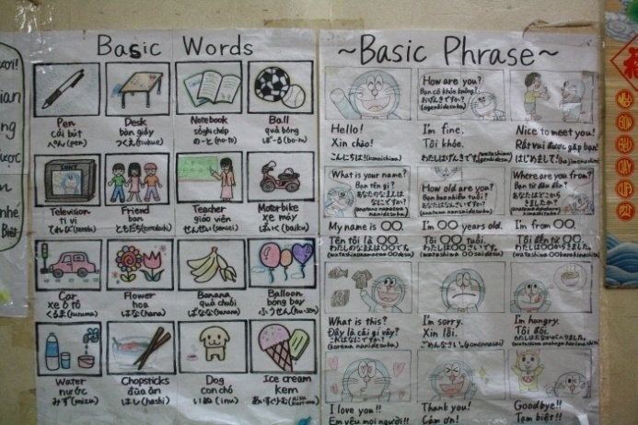 | 