INTRODUCTION
The university aims at becoming a leading Hanoi-based University in region based in fields of Natural Resources and Environment. The university was founded in 2005 and located in Cau Dien area in Tu Liem District, which is about 8km far from the city center.

VOLUNTEER’S ROLE
Volunteers are needed to help the students and lecturers in improving English skills at Hanoi University of Natural Resources and Environment (HUNRE) with following tasks:
· Teaching English for about 5-10 lecturers of all departments who are beginners in English per class.
· Working as English teaching assistants to teach English with lecturers of Department of Foreign Languages in all faculties.
· Teaching English for beginner students.
· Assisting lecturers of Department of Foreign Languages in preparing teaching materials.
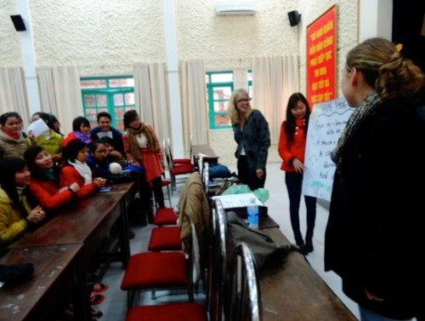
WORKING TIME
Working time will be from 8.00 am to 5:30 pm but changeable (Depend on the schedule for specific volunteer)

LUNCH
The university does not provide lunch meals for volunteers but there are a lot of street restaurants around. Each volunteer is provided 30.000 dong for lunch. He/she will pay in advance and get the reimbursement every Tuesday. An email is required to send to admin@vpv.vn indicating number of meals and bus tickets (if any) with the total amount of money. Hong, who takes charge of finance, will check and return money to volunteers.
Here are some common dishes with prices:
+Noodles (any kinds): 25.000-30.000 dong/bowl.
+Rice: 25.000-30.000 dong/dish.
(Give the money to the seller and point at the food that you want, the seller will pick them into your dish until it reaches the limit of your money)
+Bread: 15.000-30.000 dong/bread (Depend on how big it is).

TRAVEL TO PROJECT
Volunteers travel to project by bus, which usually takes up to 40 minutes.

CONTACT:
Contact HUNRE:
Address: Cau Dien, Tu Liem District, Hanoi
Mentor: Mrs. Linh (English teacher)
Email: tranthuylinh0412@gmail.com

Contact her to:
- Inform when you are sick or late, if it is possible one day in advance because they need to know in order to make the work schedule.
- Information about organizational issues: logistics, timetable, meals, sleeping room after lunch, work material, etc.
- Help with related problems at work.
At VPV Office:
The coordinator in VPV head office is Duc
Contact: Duc
Tel.: 0978 017 992
Address: No. 56, Lane 99, Nguyen Phong Sac Street, Cau Giay District, Ha Noi.
Mail: individual@vpv.vn

DO’S AND DON’TS AT THE PROJECT
- Dress more conservatively when teaching at the school. It is not considered appropriate showing knees or shoulders.
- Do not smoke in the school, even in the garden or open-air areas. It is a bad model for the children or adolescents. Neither give nor accept cigarettes from teenager students. If you are a smoker please leave the school area to smoke.
- Do not lose your temper in public. Even if you are frustrated or feel you are being mistreated, to show anger will be seen as a serious loss of face and will rarely help you achieve what you want. It is more effective to smile, show patience and ask again about what you need.
- Do not correct the English teachers in front of other teachers or students. You should avoid hurting the others feelings. During your speaking and pronunciation exercises you will have the chance to correct all the mistakes you feel necessary to correct.
- Be friendly with the students but not easy. Students should respect you as a teacher not a friend in the class.

TRAVEL GUIDE
Volunteers normally take the buses number 39 then 05 to come to the university. It costs 7,000 VND per ride. You need to collect the bus tickets and give to Mrs.Hong to get reimbursement (mentioned above). If you have the bus pass, just show them to the ticket inspector on the bus.

*Instructions:
-Walking to the bus stop right next to the lane of our house
-Take the bus no.39 and be on the bus around 5 minutes
-Get off when the bus turns right
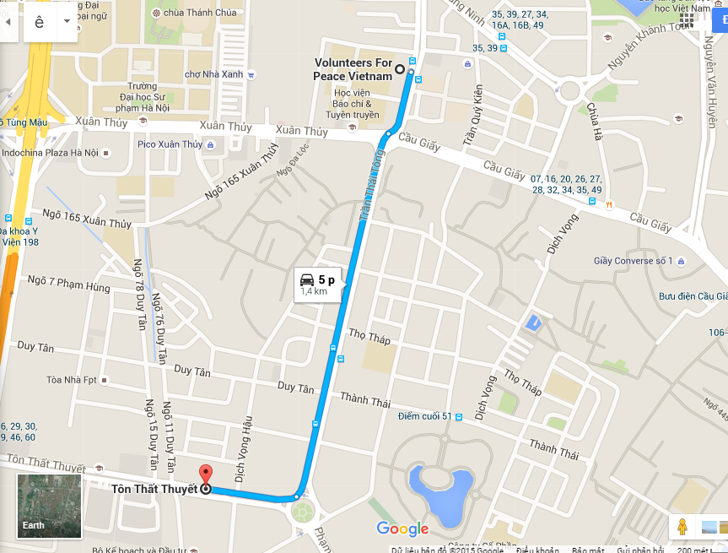
-Take the bus 05, which directly go to the university
-Get off at the 1st bus stop after the bus crosses a bridge then turn right to Phu Dien street

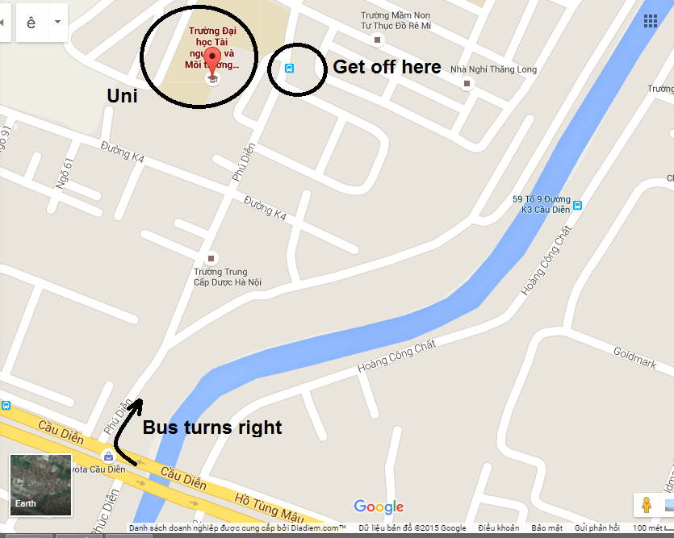
-On the way back, take the bus 05 at the bus stop in front of the university
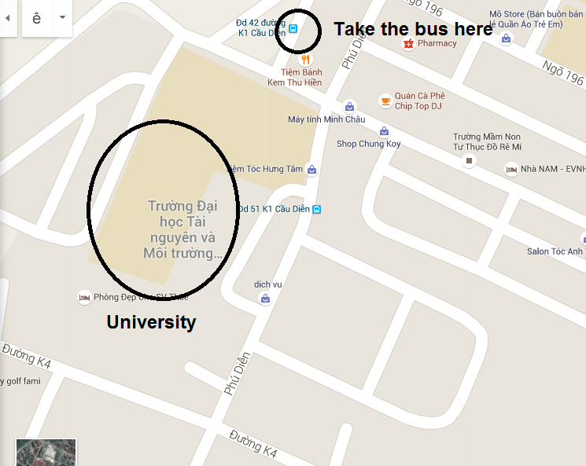
-Get off after seeing My Dinh bus station
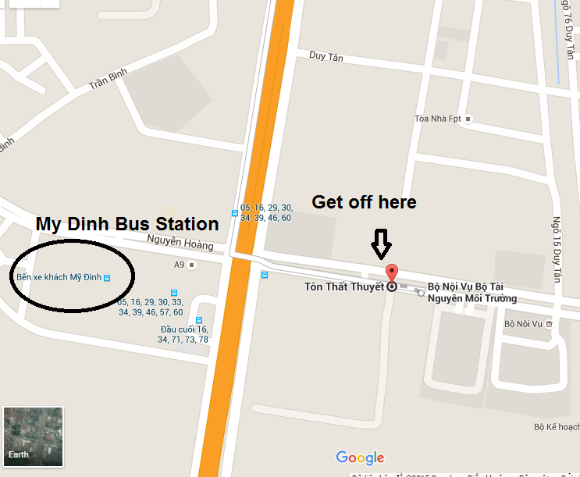
-Take the bus no 39 back to the house
