INTRODUCTION
The Hope Center is a non-profit, non-governmental day care organization based in Hanoi for the care of mentally and physically impaired children. The center was founded in 1997 by Vietnamese enthusiastic teachers, and then in 2002, it was expanded with the support from an American NGO.
Number of staff: 17 teachers. All of them graduated from Hanoi National University of Education. Mrs. Nga, the director, is not only a teacher but also a doctor of Pediatrics.
Number of children: 65 disabled children divided into four classes. The number of children changes from time to time.
The center’s mission is to provide opportunities for children with mental and physical impairment to receive an education and to feel included with their local community. In particular, the center provides assistance for those children suffering from developmental disabilities including Down's syndrome, Autism and Cerebral Palsy. As well as early grade academic learning, the education programs include physical education and therapy, yoga, painting and poetry.

VOLUNTEER’S ROLE
With professional experience or qualifications in the field of care for children with learning difficulties, Down's Syndrome, Cerebral Palsy or Autism, a volunteer will be able to help staff with clinical and special educational assistance, including these activities:
- Caring for disabled children
- Improving speaking skill: some kids can’t speak so you can talk with them in your language to make them speak to you
- Assisting teachers (joining the class for Math, English, Drawing, Singing and Handwork)
- Feeding the children during lunch time
- Playing games with children
- Calling for charity or Subscription (depends on volunteers)
- Charity campaign for books, old clothes, old shoes for the children here (depends on volunteers)
Especially, we encourage volunteers to organize their own activities such as playing music, teaching dancing… because music and dancing are very good for the kids.

WORKING TIME
The center starts working at 8:00 a.m but volunteers can work from 8:30am. Volunteers will work until 11:00 and have a long break from then to 2:00 p.m. The afternoon section lasts until 4:00-4:30 p.m.

LUNCH
There are several options for lunch.
Volunteers can eat lunch with the staffs if they wish. In this case, volunteers need to inform the center in advance to prepare food for them.
Due to the long lunch break, volunteers can also go back to VPV house to eat lunch. In this case, volunteers just need to tick for their meals on the meal list in the house one day in advance.
If prefer, volunteers can eat at some street restaurants nearby the Hope Center. In this case, volunteers get support of 30.000VND for lunch. They will pay in advance and get the reimbursement on a weekly basis.
Here are some common dishes with prices:
+Noodles (any kinds): 25.000-30.000 dong/bowl.
+Rice: 25.000-30.000 dong/dish.
(Give the money to the seller and point at the food that you want, the seller will pick them into your dish until it reaches the limit of your money).
+Bread: 15.000-30.000 dong/bread (Depend on how big it is).
An email is required to send to admin@vpv.vn stating number of lunch and respective date. VPV admin will check and reimburse money (30,000VND*number of lunch) to volunteers on an agreed date/time.
TRAVEL TO PROJECT
Volunteers normally take the bus number 34 to the project, which costs 7,000 VND per ride. Volunteers need to collect the bus tickets and give to VPV admin to get reimbursement (same procedure with lunch refund). Those who stay more than two weeks should provide a picture to VPV to make a bus pass. With the bus pass, volunteers just need to show it to the ticket inspector on the bus.

CONTACT:
*At Hope Center:
The mentor in Hope Center is Mrs. Nga.
The mentor is the person who will be in charge of the volunteer in the placement. Contact her to:
- Inform when you are sick or late, if it is possible one day in advance because they need to know to make the work schedule.
- Information about organizational issues: logistics, timetable, meals, sleeping room after lunch, work material, etc.
- Help with related problems at work. Usually the mentor is the person in the center. As she can speak little English she will be useful and try her best to be a translator between the local staff and the international volunteer.
The coordinator responsible in VPV head office is Mai.
Contact Hope Center:
Address: No 4, 82/189 back street, Alley 290, Kim Ma Street, Ba Dinh district, Hanoi.
Phone: 04 37 260 200, email : hopecenterhn@gmail.com
Director and mentor: Mrs. Nga

Contact VPV: Mai
Address: No.56, lane 99, Nguyen Phong Sac Street, Cau Giay, Hanoi, Vietnam
Phone: 0904988445
Mail : coordinator@vpv.vn
CHALLENGES AND RECOMMENDATIONS

- Some of the disabilities you may see in the centers can be shocking to you and you may have problems to get in contact with the children. But if you try you will see that they are really lovely and excited to get to know you and play with you.
- Do not expect that the center has been waiting for you. They will not have a concrete task for the volunteers and just give you a random and perhaps useless job. Thus, volunteers are expected to come up with their own activities.
- Teaching the children can be difficult in more than one way. Be prepared for this and maybe prepare something in advance before you have your first working day.
- The way the children might be treated can be shocking and unfair to us. Often the teachers hit their students for no obvious reasons or you may see children being left alone in the room. Often staff and carers are poorly trained, poorly paid, grossly overworked and therefore poorly motivated. Maybe you can use your time in the center to support them which will hopefully lead to a better treatment of the children. However, you should also have in mind that Vietnamese and western understanding of a good education don not always match. Hitting a student is probably a commonly used way to discipline the child.
- Often the children appear dirty and unkempt. Sometimes one carer is responsible for more than 20 severely disabled children, they may not manage to look after all of the children carefully. Since you do have the time, maybe you can help by supporting the children brushing their teeth or washing their hands.
- Another problem is the language barrier. The most part of the staff doesn't speak English. Some of the children may not even be able to speak Vietnamese; the communication in English is most of the time impossible. However, it is a lot of fun, to talk by using hands and feet. It could be useful to learn some sign-language then teach the children how to use it.
Please note that you may not feel the immediate impacts on the children’s progress during your stay because the children’s situation is really severe and the progress can only be recorded after years. Therefore, the gradual and continuous support from volunteers can foster the speed of progress in a positive way. It has effects on not only the children but also the teachers as it may bring the inspirations or different points of view on educating children to them.

PHOTO GALLERY
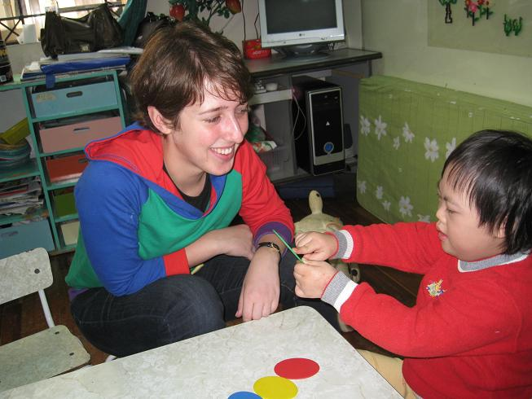 | 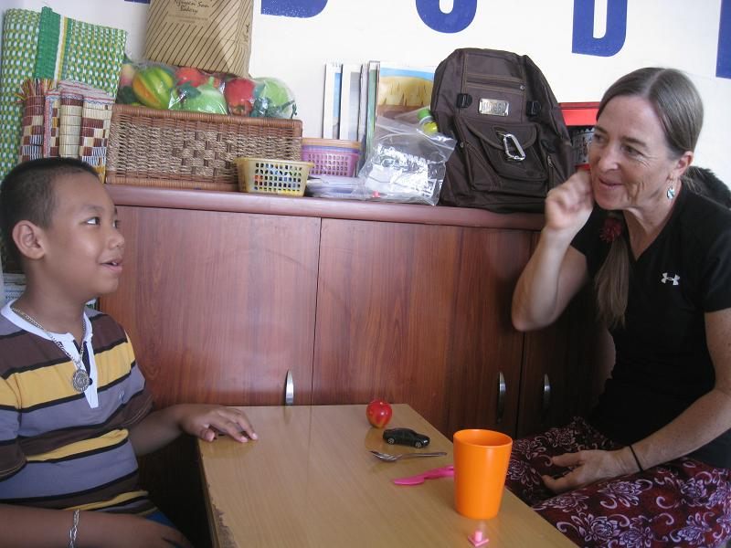
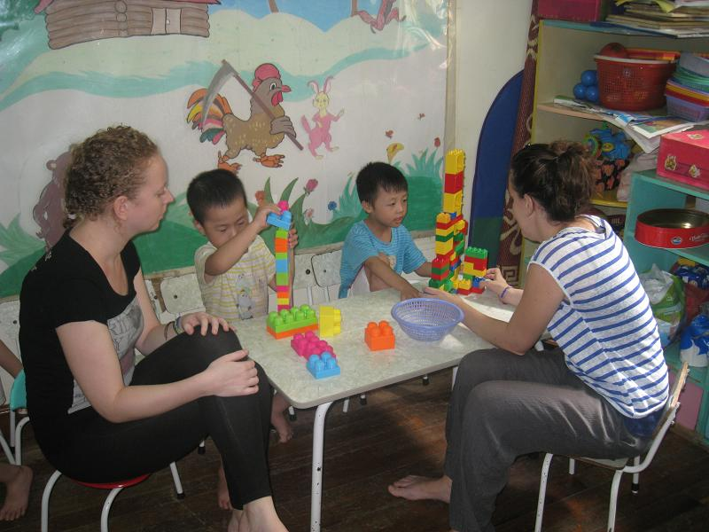 | 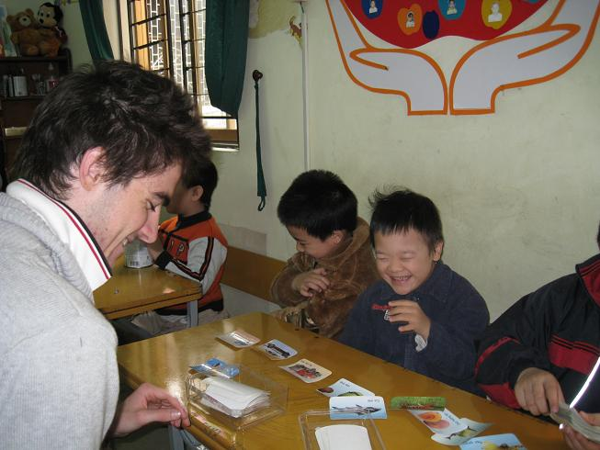
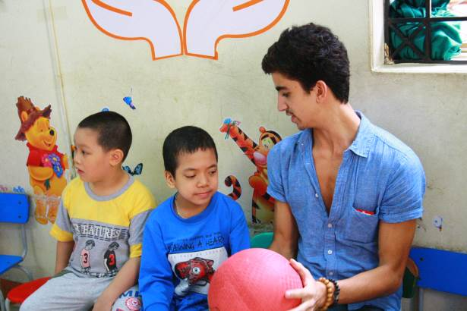 | 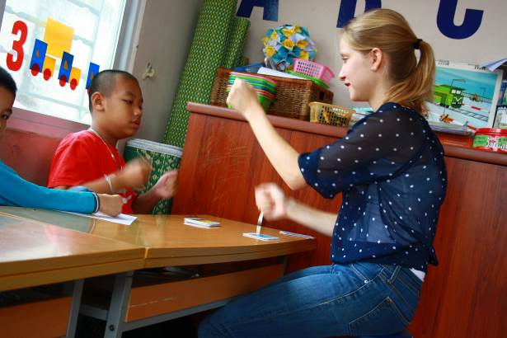
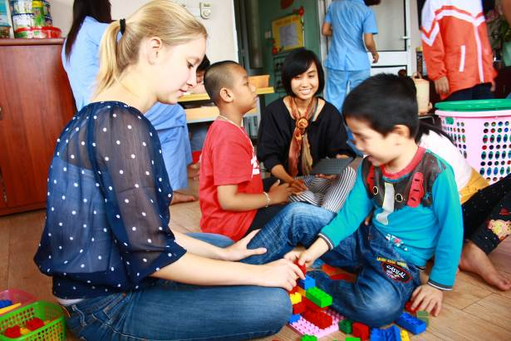 | 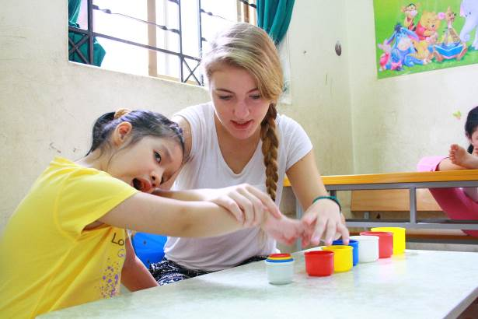
TRAVEL GUIDE
Volunteers normally take the buses number 34 to come to the center. It costs 7,000 dong per ride. Volunteers will pay for bus tickets in advance and get the reimbursement every Tuesday. An email is required to send to admin@vpv.vn with the content including the number of bus tickets (if any) with the total amount of money. Hong, who takes charge of finance, will check and return money to volunteers. If you have the bus pass, just show them to the ticket inspector on the bus.
*Instructions:
-Walking to the bus stop right opposite to the lane of our house
-Take the bus number 34
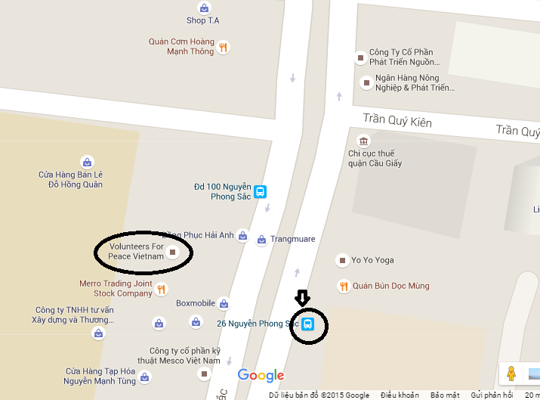
-Get off at the bus stop after seeing Swedish Embassy on the left
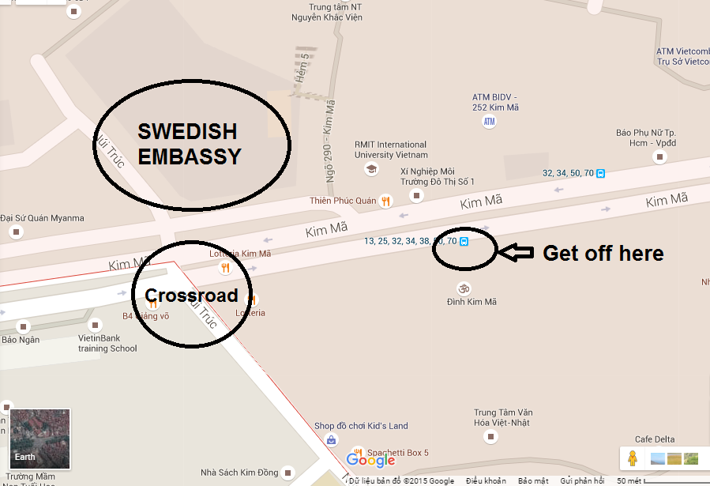
- Cross the street to 290 Alley and then walk though alleyways (follow signs “Trung Tam Hy Vong” to the center).
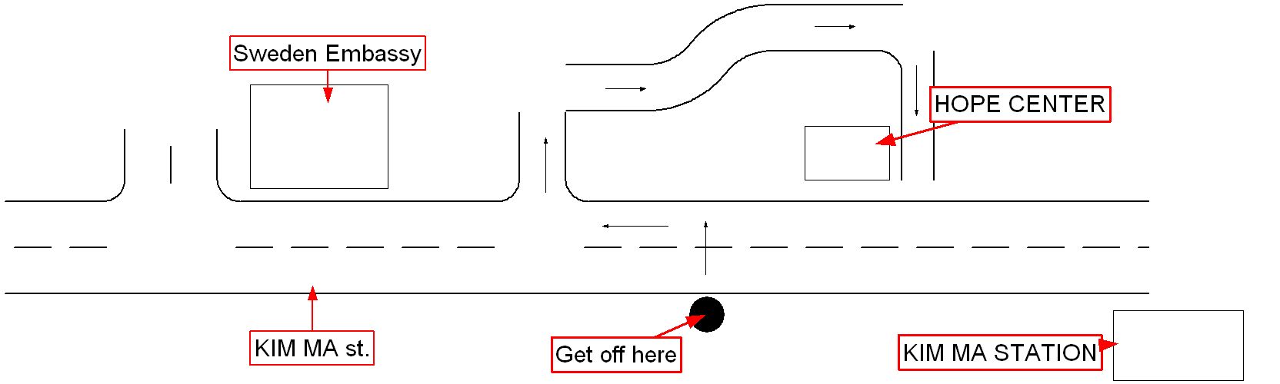
-To go back to the volunteers’ house, walk back to Kim Ma Str., turn left and take the bus 34 at the nearest bus stop.
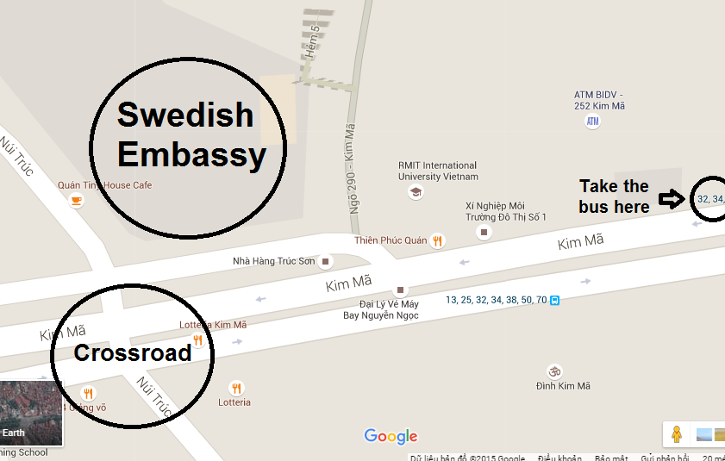
-Get off the bus after seeing White House restaurant on the right.
