INTRODUCTION

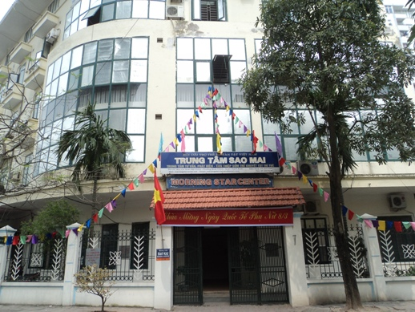
The Morning Star Center is a non-profit, non-governmental organization founded in December 1995 for the early detection and care of mentally impaired children. Chaired by Professor Nguyen Tai Thu, it is a subsidiary of the Vietnam Relief Association for Children with Disabilities and has 90 staff members caring for approximately 186 children ranging in age from 1 to 16 divided into 19 classes. The number of children changes from time to time.
The Center is to be found in Thanh Xuan district in South West Hanoi. Amongst the staff are teachers, psychologists, nurses, doctors and physiotherapists whose mission is to promote charitable activities that help to provide opportunities for children with mental impairment to receive an education, and to feel included with their local community. In particular, the center strives to provide assistance for those children suffering from developmental disabilities including Down syndrome, Autism and Cerebral Palsy.
Furthermore, the center has begun offering some vocational and pre-vocational courses for teenagers, in addition to sending them to outside vocational schools. The courses help increase the children's independence and confidence, and their abilities to get enrolled in professional training centers outside. Having recently set up a coffee shop at the entrance of the center, some of the children help out and in the process receive valuable experience in working and interacting with the public.

VOLUNTEER’S ROLE
The Morning Star Center is well-organised with clear schedule for each class. Therefore, when volunteers participate in taking care of the kids, they can easily follow the activities in the class. Because there are mere 10-20 children in a class, the teachers are hardly to give regular care to each individual. Hence, the volunteers will play a role as an assistant, a carer and a teacher who shares the work with the teachers and give more focus on children.
There are some listed activities that volunteers can do with the kids:
- Caring for Autistic children
- Playing with the children with provided toys
- Helping them do some movements (walking, standing up or jumping…)
- Washing hand, face for the children.
- Teaching them how to wash their hands or wear clothes…
- Taking them out of the class for a walk if necessary.
- Supporting the children to take the table and chair for learning.
- Assisting teachers in Math and Vietnamese writing lessons.
- Helping the children with drawing and coloring.
- Cleaning floor or toilet or toy.
- Helping teacher to stretch the mattresses on the floor.
- Guiding & helping the children go and use toilet.
- Feeding the children during lunch time
- Guiding the children who are not able to feed by themselves.
- Helping the teacher to make teaching material as drawing, painting, modeling (depending on volunteer’s ability)
- Sharing with the teacher about teaching methods.
- Organizing games and other activities for children
- Calling for charity or Subscription, editing document(depends on volunteers)

WORKING TIME
Working time will be from 8.30 am to 4 pm with a lunch break from 11:30 am to 2 pm.

LUNCH
Volunteers can have lunch in the center. If so, volunteers have to register in the morning before 9 AM. If volunteers would like to have a meal outside, do not need to inform the center in the morning. Normally a volunteer is provided 30.000 dong for lunch. He/she will pay in advance and get the reimbursement every Tuesday. An email is required to send to admin@vpv.vn indicating number of meals, bus tickets (if any) with the total amount of money. Hong, who takes charge of finance, will check and return money to volunteers.
Here are some common dishes with prices:
+Noodles (any kinds): 25.000-30.000 dong/bowl.
+Rice: 25.000-30.000 dong/dish.
(Give the money to the seller and point at the food that you want, the seller will pick them into your dish until it reaches the limit of your money)
+Bread: 15.000-30.000 dong/bread (Depend on how big it is).

TRAVEL TO PROJECT
Volunteers travel to work by bus, which takes up to 1 hour.

CONTACT:
Morning Star Center:
Address: 116 Alleys, Nhan Hoa Street, Nhan Chinh Commune, Thanh Xuan District, Hanoi
Director: Mrs. Lan (0903 236 633)
Mentor: Ms. Van (0169 407 8590)
The mentor of Morning Star Center is Ms. Van, who will be in charge of the volunteer in the placement. Contact her to:
- Inform when you are sick or late, if it is possible one day in advance because they need to know to make the work schedule.
- Information about organizational issues: logistics, timetable, meals, sleeping room after lunch, work material, etc.
- Help with related problems at work. As she can speak English she will be useful as a translator between the local staff and the international volunteer
At VPV Office:
The coordinator in VPV head office is Mr. Duc.
Contact: Mr. Duc
Tel.: 0978 017 992
Address: No. 56, Lane 99, Nguyen Phong Sac Street, Cau Giay District, Ha Noi.
Mail: individual@vpv.vn
Youth House Manager: Mr. Thai
Phone: 09 757 397 88
Mail: supervisor@vpv.vn
Emergency contact: (accident, hospitalization)
Mr. Duc: 0978 017 992 individual@vpv.vn
Mrs. Mai : 0904 988 445 coordinator@vpv.vn
Mr. Phuong: 0987 666 878 phuongdon@vpv.vn

CHALLENGES AND RECOMMENDATIONS

Do not expect that the center has been waiting for you. The teachers are busy with the kids so they may not give the volunteers concrete tasks or just give you a random and perhaps useless job instead. If you feel so, firstly observe carefully what the teachers are doing with each child (Taking notes may be useful) then try to immitate these activities and do it with the kids (with the permission of the teachers). Besides, regular discussions with project coordinator, VPV coordinator are necessary to enhance the cooperation between the teachers and volunteers.
The way, the children might be treated can be shocking and unfair to us. Sometimes the teachers hit their students for no obvious reason or you may see children being locked in their rooms and left alone. Often staff and careers are poorly paid, grossly overworked and therefore poorly motivated. Therefore, volunteers are expected to support them which will hopefully lead to a better treatment of the children. However, you should also have in mind that Vietnamese and western understanding of a good education don’t always match. Hitting a student is probably a commonly used way to discipline the child.
Sometimes the children appear dirty and unkempt. Sometimes one career is responsible for more than 20 severely disabled children, they may not manage to look after all of the children carefully. Since you do have the time, maybe you can help by supporting the children brushing their teeth or washing their hands.
Another problem is the language barrier. Most of the staff does not speak English. Some of the children may not even be able to speak Vietnamese; the communication in English is most of the time impossible. However, it is a lot of fun to talk by using hands and feet. It could be useful to learn some sign-language, since many of the children in the centers are mute and/or deaf.
Please note that you may not feel the immediate impacts on the children’s progress during your stay because the children’s situation is really severe and the progress can only be recorded after years. Therefore, the gradual and continuous support from volunteers can foster the speed of progress in a positive way. It has effects on not only the children but also the teachers as it may bring the inspirations or different points of view on educating children to them.

TRAVEL GUIDE
Volunteers normally take the buses number 39 to come to the center. It costs 7,000VND per ride. You need to collect the bus tickets and give to Mrs. Hong to get reimbursement (mentioned above). If you have the bus pass, just show them to the ticket inspector on the bus.
*Instructions:
-Walking to the bus stop right next to the lane of our house
-Take the bus no.39
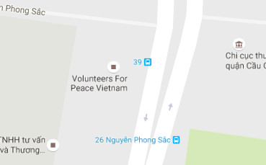
- Get off after the bus pass two big intersections since it pass the Hanoi Museum.
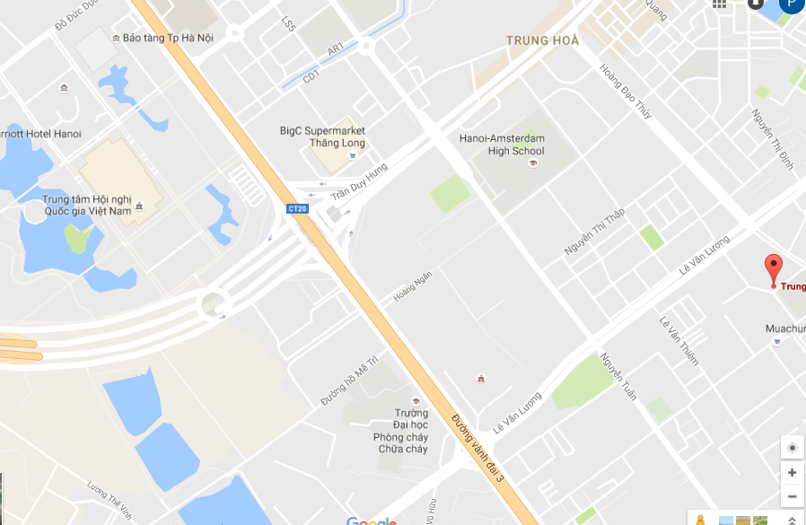
Hanoi Museum
- Then you walk to the center, it is behind the Hei Tower.

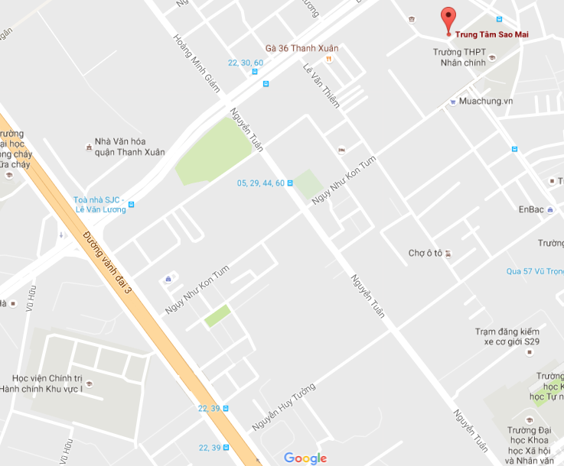
You get off here
Morning Star Center
You take the bus here to go back

- On the way back, go back to the big street and take the bus 39. (The bus stop is opposite to the one that volunteers get off).
- When you see the crossroad with Urban Station coffee on your left and Maxx coffee on your right, get off at the next bus stop. Walk to the other side of street and go back to the house.
PHOTO GALLERY
