INTRODUCTION

Established by a German non-profit organization, the Thanh Xuan Peace Village provides supervision and care for over 110 second and third generation children who are victims of Agent Orange, an herbicide and defoliant used by the U.S. The center has about 50 staff members amongst which are caretakers, physiotherapists, massage therapists, teachers, cooks and doctors.
Facilities at the Peace Village include dormitory residence, two physiotherapy treatment rooms, a playground, a communal dining hall, classrooms, technical training workshops and health clinic.
The aim of Peace Village is to give every effected child the chance and opportunity to lead normal, happy and fulfilled lives. Clearly, given the circumstances this is no easy task, and although, thanks to the dedicated work of those at Peace Village, tremendous work has been made, there still remains much work to be done.
Volunteers will work mainly in 3 classes: 2 special education classes and 1 pre-school class. The number of children in one class fluctuates from 10 to 20, and varies day by day (depending on the parents). Most of them are mentally handicapped children with different levels of disability. The age of children ranges from 5 to 25 years old.

VOLUNTEER’S ROLE
Volunteers are always welcomed to give care, joyfulness, entertainment to the children at the center. The teachers (the nurses in fact) are hospitable and open-minded to any ideas that volunteers bring here. It is both opportunities and challenges for volunteers. On the one hand, volunteers can freely introduce any activities that cheer the children up and educate them without any limitations from the center but on the other hand, some volunteers who are not proactive and creative may feel disoriented and useless in the class because the nurses, who are lack of teaching experience, often do nothing but supervise the kids or showing some movies/music. There are a numerous explanations such as the short of well-trained staff, low salary, poor management and the others. Hence, volunteers are expected to not only give care to the kids but also bring a new and fresh atmosphere to the people here.
There are some listed activities that volunteers can do with the kids:
  - Washing the toys
  - Playing soccer at the playground
  - Playing with the small balls (throw the balls in the basket)
  - Jumping through rings (I layed the rings on the ground and then the kids can jump through them)
  - Playing with Play Do (I made play do with flour, water and salt)
  - Colouring
  - Cutting
  - Folding paper
  - Make some simple handicrafts
  - Blowing bubbles with your hands with soap and water
  - Make a puzzle
  - Give the kids some music instruments and let them play
  - Singing songs

WORKING TIME
The center starts working at 8:00 a.m but volunteers can work from 8:30. However, if volunteers are interested in joining morning exercise section with the kids, they can arrive at 8. Volunteers will work until 11:00 and have a long break from then to 2:00 p.m. The afternoon section lasts until 4:30 p.m.

LUNCH
The center does not provide lunch meals for volunteers but there are a lot of street restaurants around. A volunteer is provided 30.000 dong for lunch. He/she will pay in advance and get the reimbursement every Tuesday. An email is required to send to admin@vpv.vn indicating the number of lunch meals, bus tickets (if any) with the total amount of money. Hong, who takes charge of finance, will check and return money to volunteers.
Here are some common dishes with prices:
+Noodles (any kinds): 25.000-30.000 dong/bowl.
+Rice: 25.000-30.000 dong/dish.
(Give the money to the seller and point at the food that you want, the seller will pick them into your dish until it reaches the limit of your money)
+Bread: 15.000-30.000 dong/bread (Depend on how big it is).

TRAVEL TO PROJECT
Volunteers travel to the project by bus which takes up to 40 minutes.

CONTACT:
*At Peace Village:
The mentor of Peace Village is Ms. Tu.
The mentor is the person who will be in charge of the volunteer in the placement. Contact her to:
- Inform when you are sick or late, if it is possible one day in advance because they need to know to make the work schedule.
- Ask for help related with problems at work. Usually the mentor is the person in the center. As she can speak English, she will be useful as a translator between the local staff and the international volunteers.
Address: No.35, Le Van Thiem Str., Thanh Xuan District, Hanoi, Vietnam
Mentor: Ms. Tu (0983 155 168)
*At VPV Office:
The coordinator in VPV head office is Mr. Duc.
Contact: Mr. Duc
Tel.: 0978 017 992
Address: No. 56, Lane 99, Nguyen Phong Sac Street, Cau Giay District, Ha Noi.
Mail: individual@vpv.vn
*Emergency contact: (accident, hospitalization)
Ms. Mai : 0904 988 445 coordinator@vpv.vn
Mr. Phuong: 0987 666 878 phuongdon@vpv.vn
CHALLENGES AND RECOMMENDATIONS

- Some of the disabilities you may see in the centers can be shocking to you and you may have problems to get in contact with the children. But if you try you will see that they are really lovely and excited to get to know you and play with you.
- Do not expect that the center has been waiting for you. They will not have a concrete task for the volunteers and just give you a random and perhaps useless job. Thus, volunteers are expected to come up with their own activities.
- Teaching the children can be difficult in more than one way. Be prepared for this and maybe prepare something in advance before you have your first working day.
- The way the children might be treated can be shocking and unfair to us. Often the teachers hit their students for no obvious reasons or you may see children being left alone in the room. Often staff and carers are poorly trained, poorly paid, grossly overworked and therefore poorly motivated. Maybe you can use your time in the center to support them which will hopefully lead to a better treatment of the children. However, you should also have in mind that Vietnamese and western understanding of a good education don not always match. Hitting a student is probably a commonly used way to discipline the child.
- Often the children appear dirty and unkempt. Sometimes one carer is responsible for more than 20 severely disabled children, they may not manage to look after all of the children carefully. Since you do have the time, maybe you can help by supporting the children brushing their teeth or washing their hands.
- Another problem is the language barrier. The most part of the staff doesn't speak English. Some of the children may not even be able to speak Vietnamese; the communication in English is most of the time impossible. However, it is a lot of fun, to talk by using hands and feet. It could be useful to learn some sign-language then teach the children how to use it.
Please note that you may not feel the immediate impacts on the children’s progress during your stay because the children’s situation is really severe and the progress can only be recorded after years. Therefore, the gradual and continuous support from volunteers can foster the speed of progress in a positive way. It has effects on not only the children but also the teachers as it may bring the inspirations or different points of view on educating children to them.

PHOTO GALLERY
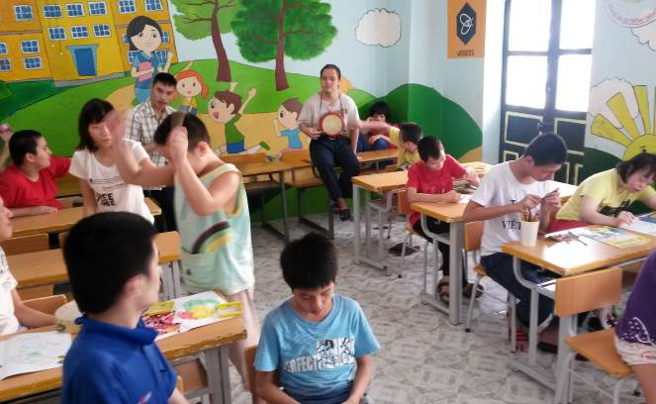 | 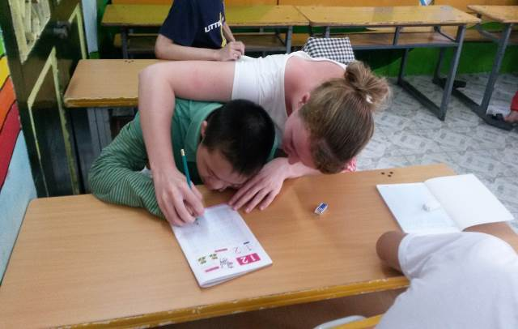
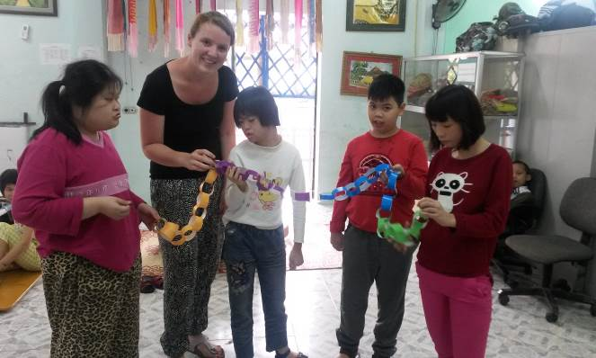 | 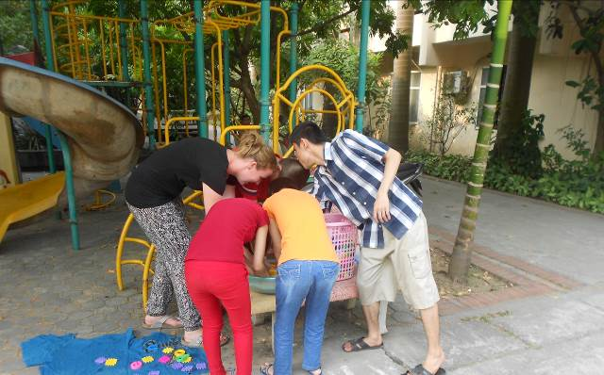
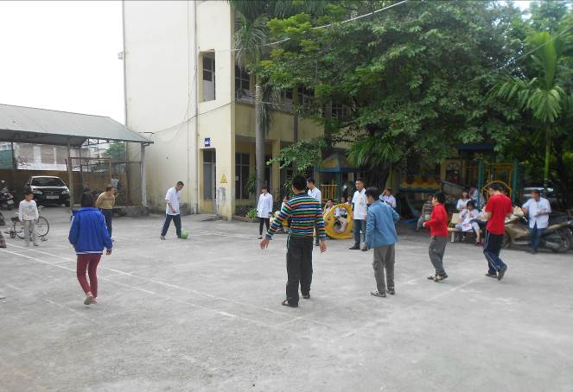

TRAVEL GUIDE

Volunteers normally take the bus number 39 to come to the center. It costs 7,000 VND per ride. You need to collect the bus tickets and give to Mrs.Hong to get reimbursement (mentioned above). If you have the bus pass, just show them to the ticket inspector on the bus.
*Instructions:
-Walking to the bus stop right next to the lane of our house
-Take the bus no.39 and be on the bus around 40 minutes.
-Get off the bus after seeing Licogi 13 Tower, the bus is in front of Thanh Xuan People Committee.
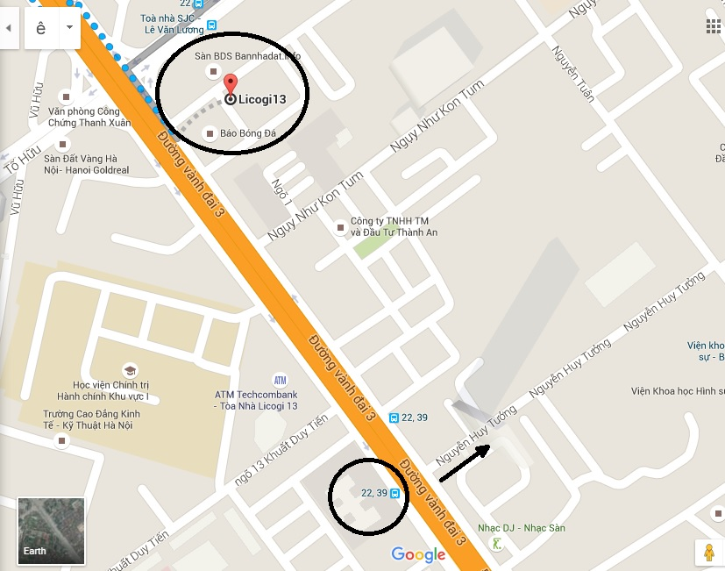
-Walk to the other side of the street and walk along Nguyen Huy Tuong Street.
-Turn left to Nguyen Van Thiem Str.
-Walk along Nguyen Van Thiem Str., then you see Peace Village on your left.
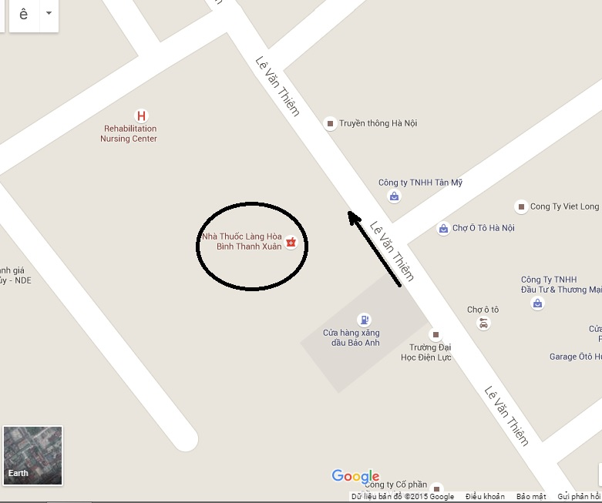
-On the way back: follow the same way back.
-Go to the main street, turn right and go to the bus stop.
