INTRODUCTION
Deriving from the fact that Vietnamese students often have a long summer vacation and the need of improving language ability is obvious, VPV Community Class was first kicked off since 2011 and now has become an annual voluntary teaching project hold by VPV with a good reputation in the Vietnamese youth community.
This project offers 2 -3 months English/French courses for the Vietnamese young people with the aim to create an English/French speaking environment to foster their language abilities as well as enhance cultural exchange among the young.
There are 2 different types of students: primary students (8-11 years old) and university/college students (18-23) who do not have so many chances to approach foreign language environments (English/French) and most of them have financial difficulties to afford language classes.

LEVELS AND CHARACTERISTICS OF THE STUDENTS

Levels:
All English/French Classes focus mainly on improving speaking and listening skills which students do not have many chances to do. The degree of difficulty is various among levels.
-Beginner: familiar topics with easy vocabulary and some practices with pronunciation qand reaction through games and songs.
-Intermediate: familiar topics with more complicated vocabulary and some practices with pronunciation and reaction through games and songs. At this level, it is recommended to encourage students to express their own opinions towards topics.
-Advanced: social related topics with controversial ideas with vocabulary and group discussions. At this level, debating skills are more emphasized and students are encouraged to express their ideas and defense them against others’ opposed opinions.
Characteristics:
-Primary school students: some studentsare quite good at English. Hence, they are really energetic and sometimes disobedient. Thus, it is necessary to control their energy not to affect other students by certain methods. Meanwhile, the others can be shy because they have not had many opportunities to communicate with foreigners before. Therefore, some games or other activities to stimulate them are welcomed and effective.
-University/College students are reserved and afraid of speaking. International volunteers should encourage them to talk more or in some certain cases, the designation is required.

VOLUNTEER’S ROLE
Volunteers are expected to be the main teachers in the classes with the support of Vietnamese teaching assistants. The possible tasks of the volunteers may include:
- Prepare lesson plans with teaching assistants
- Teach the students
- Hold and join extra activities for the students

WORKING TIME
Working time will be from 8.00 am to 5:30 pm but changeable, depending on the schedule for specific classes. Volunteers work maximum 30 hours per week including in-class activities, weekly meetings with the team and other outdoor/extra activities.

LUNCH
Volunteers have lunch at the volunteer house.

TRAVEL TO WORK
Classes take place at a nearby primary school or other locations which are in walking distance.

PHOTO GALLERY
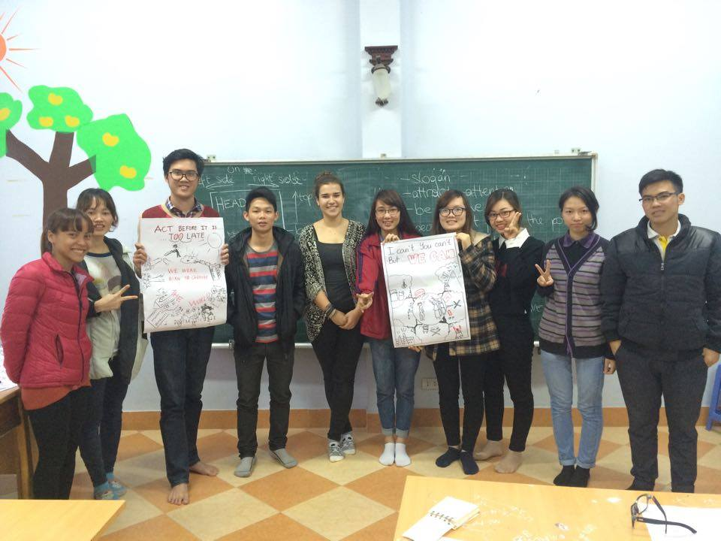 | 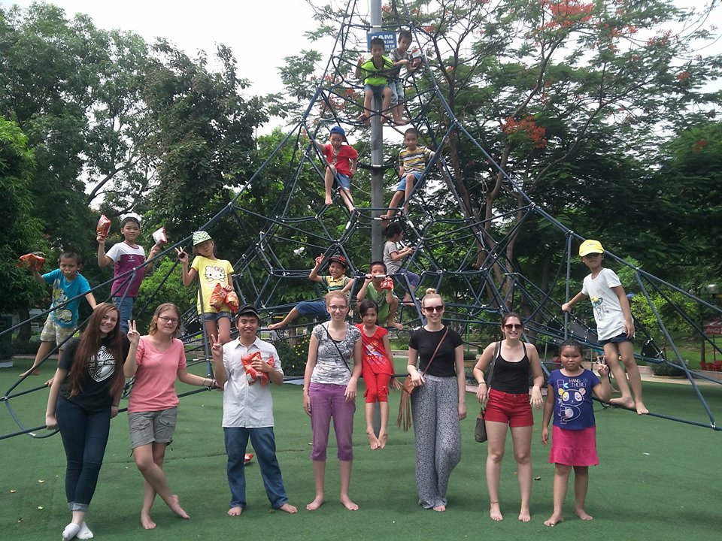
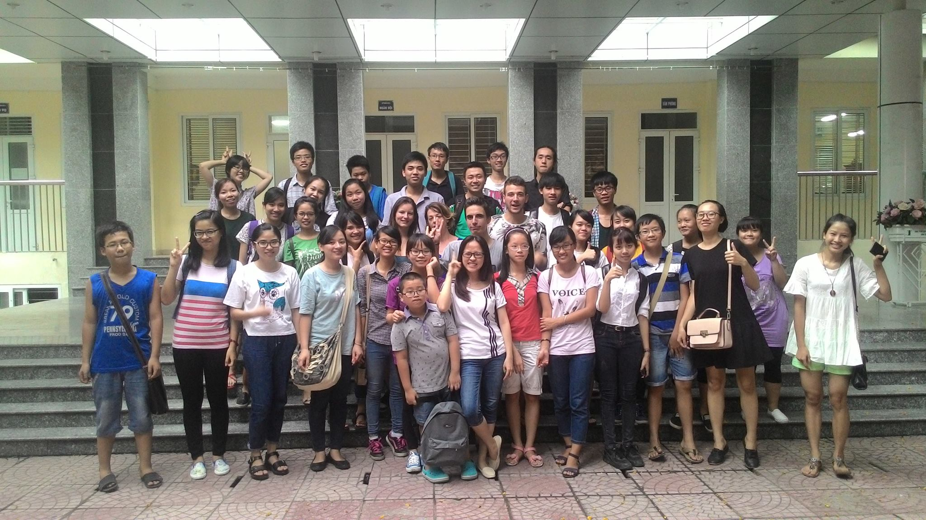 | 